FINAL PROJECT REPORT
STUDY MANAGEMENT SYSTEM
VITyarthi – Build Your Own Project

Python Console Application
Submitted as a modular academic project

Submitted By Arishvan Bhaargava

1. Introduction -
My Project is a Study Management System made using Python based console application that help students maintain basic academic information and organise their study activities . This system stores detail in text file and provide option for saving study hour, Understanding study pattern i.e (night / morning learner) , dividing available study time among various subject and scheduling examination.

2. Problem Statement
Students may Require a lightweight tool to store academic information and organize study activities without the complexity of a large database or web application. The problem handled by this project is to provide a simple menu-driven system that stores student information, records study hours, assists with study-time division, and keeps examination information in lasting storage.

3. Functional Requirements
- Student detail entry with duplicate-ID checking.
- Stores study-hour recording for a selected student daily.
- Study strategy is shown on the basis of selected morning/night study pattern.
- Study-time allocation among a comma-separated list of subjects.
- Examination scheduling with name, date, pattern and time.
- Persistent reading and writing of records using the file “student_data.txt”.
- Menu-based interaction with an exit option.

4. Non-functional Requirements
- Usability: a simple numbered console menu is used.
- Maintainability: different executing function are divided into python modules.
- Reliability: invalid and file not found are used in program to assure reliability.
- Resource efficiency: project uses a lightweight text file to store data with Python features.
- Error handling: invalid IDs, numeric input and duplicate IDs are checked in the implemented functions.
- Portability: no external Python package is required for the application itself.

5. System Architecture
The system uses a small modular architecture. main.py controls the menu, feature modules contain the original application functions, and storage.py handles persistent text-file operations.
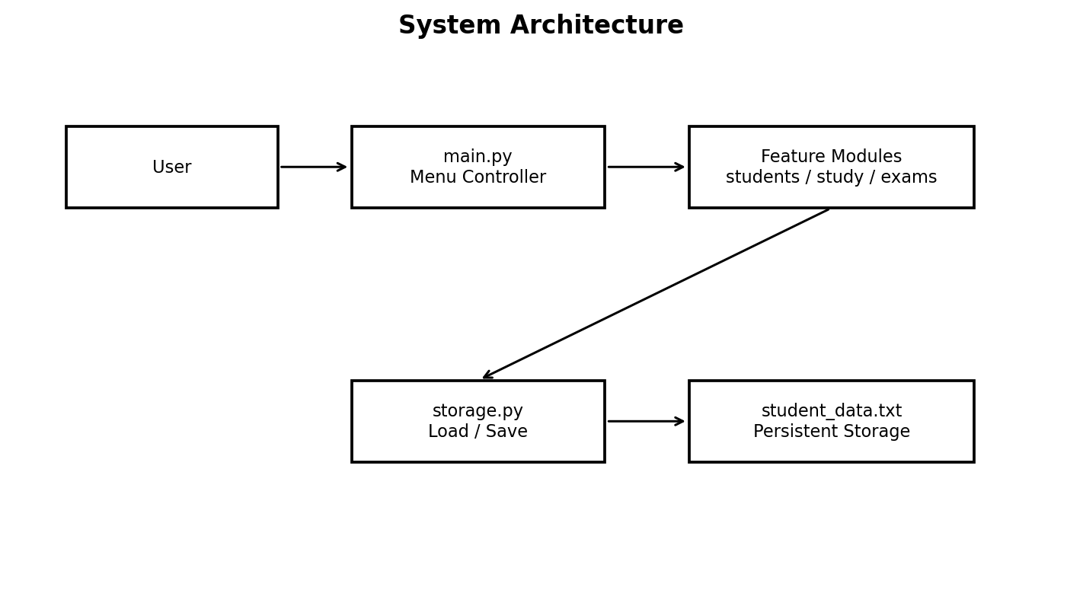

6. Design Diagrams

6.1 Use Case Diagram
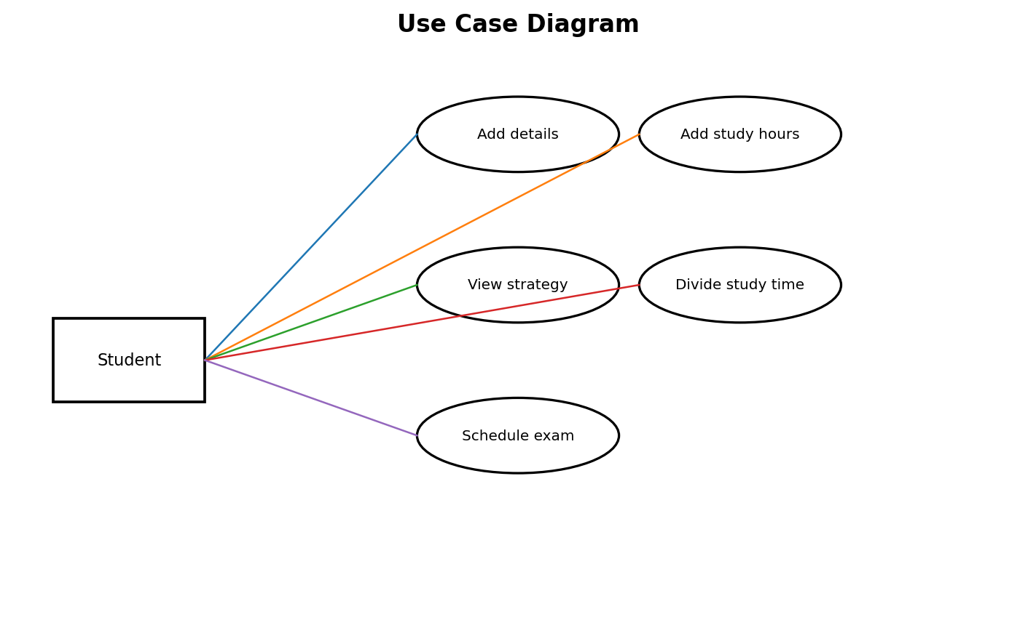

6.2 Workflow Diagram
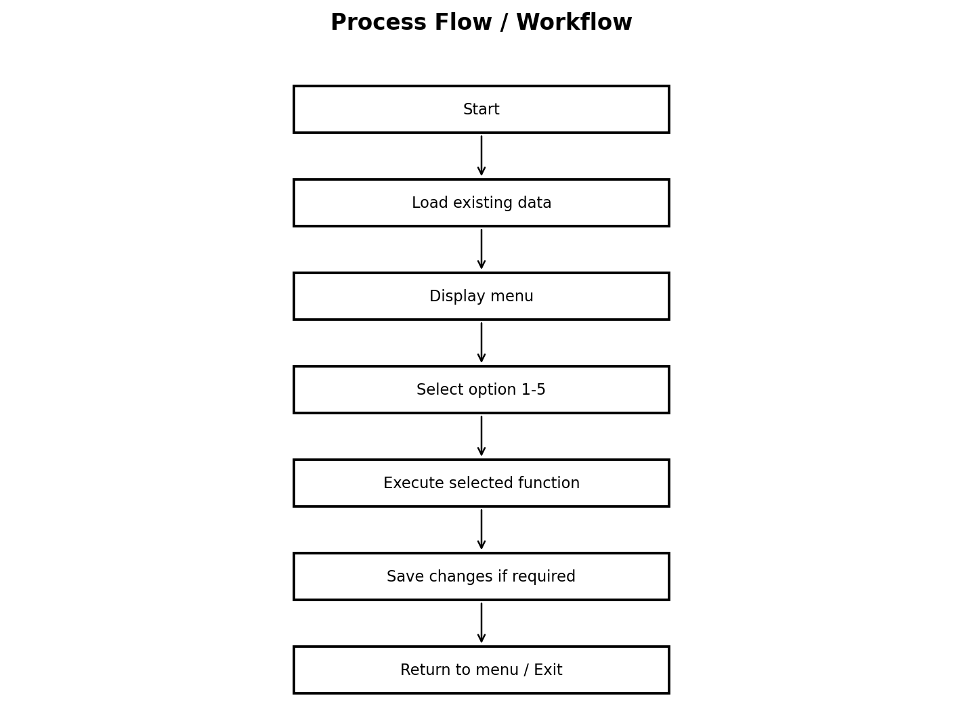

6.3 Sequence Diagram
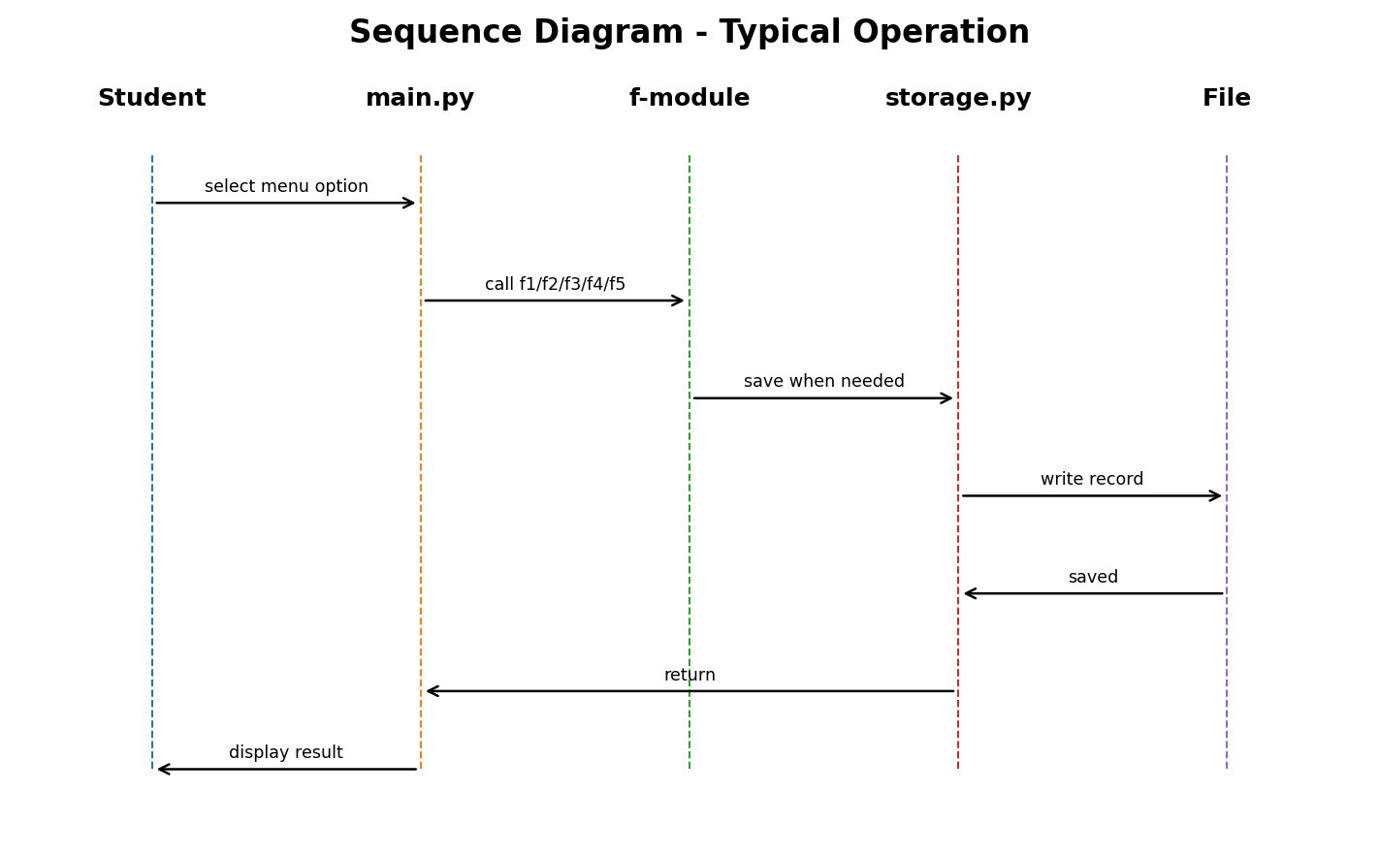

6.4 Component Diagram
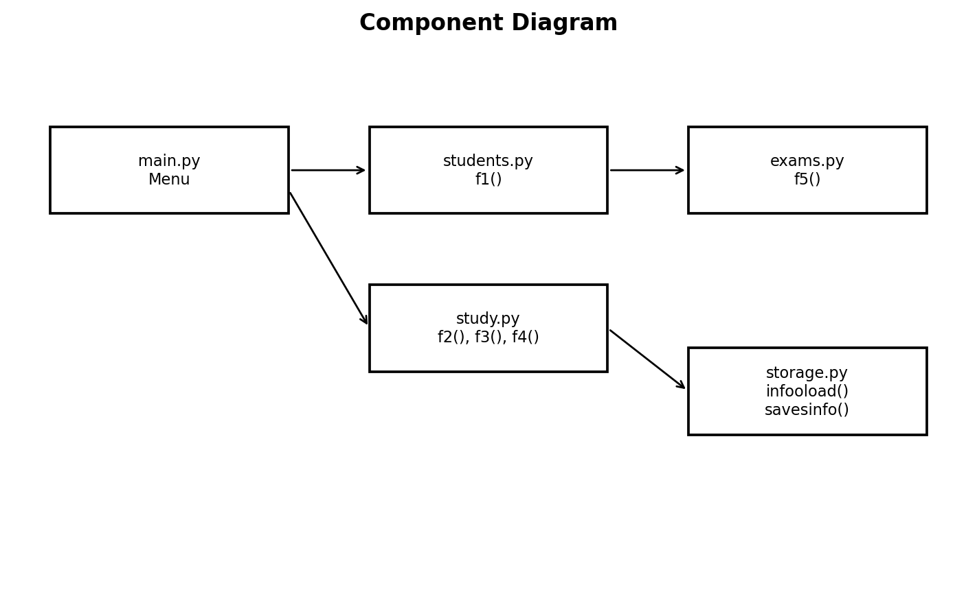

6.5 Storage / Schema Design
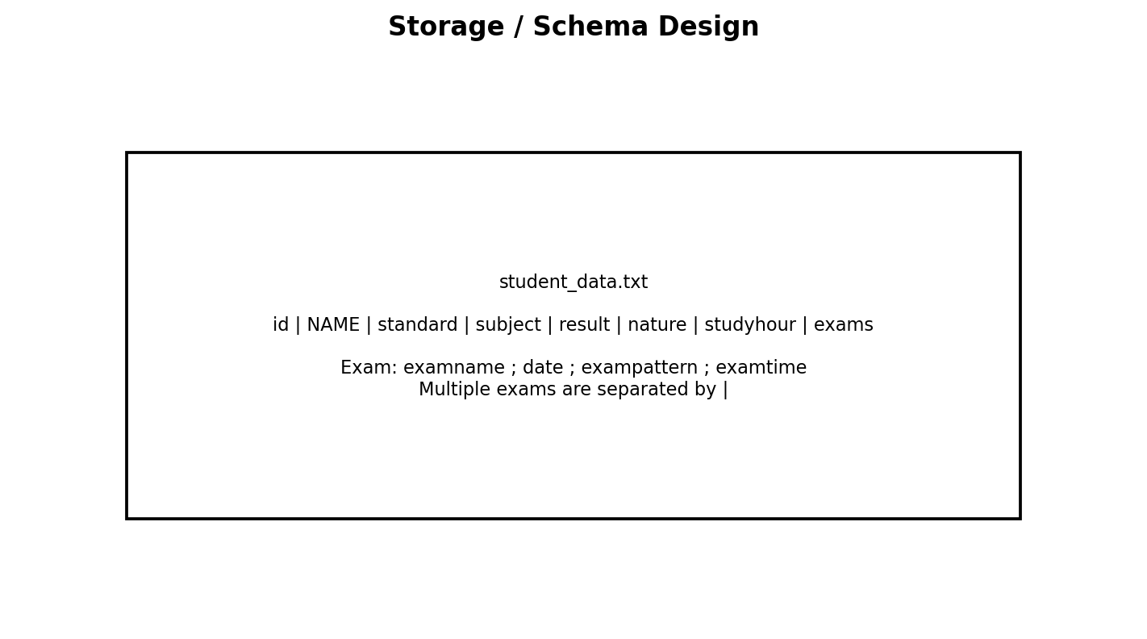

7. Design Decisions & Rationale
• Text-file storage: I used plain text files instead of a heavy database because the project is just a small school assignment.
• Preserved function names: I kept the original code names so the new version matches the original project plan perfectly.
• Separated modules: I split one massive code file into smaller, organized files grouped by what they do.
• Simple delimiters: I used simple symbols like commas to separate data so they wouldn't need to download extra software.
• Console-based: I kept the program running as text in a terminal instead of making a fancy visual app.

8. Implement details
The project contains six Python source modules. storage.py contains infooload() and savesinfo(). students.py contains f1(). study.py contains f2(), f3(), and f4(). exams.py contains f5(). state.py loads the shared details list, and main.py provides the application menu.
Module | Main responsibility | Original functions
storage.py | Load/save persistent records | infooload(), savesinfo()
state.py | Initial shared data load | —
students.py | Add student details | f1()
study.py | Study functions | f2(), f3(), f4()
exams.py | Exam scheduling | f5()
main.py | Menu/controller | —

9. Screenshots / Results
A representative program run was executed using the modularized source. The output demonstrates menu navigation, student creation, study-hour entry, strategy display, time division, and exam scheduling.
- Starting of program and adding details:
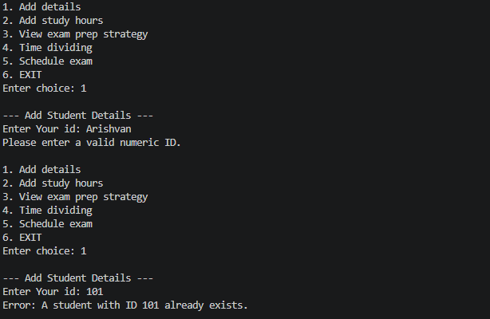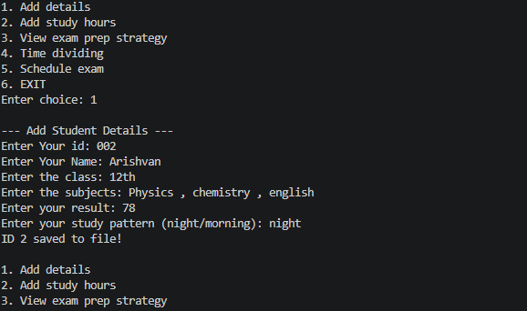
- Adding study hour and understanding the study pattern opt:
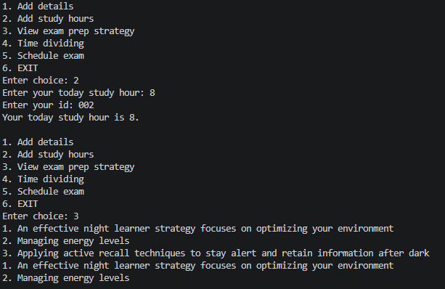
- Dividing time among subjects and scheduling exam:

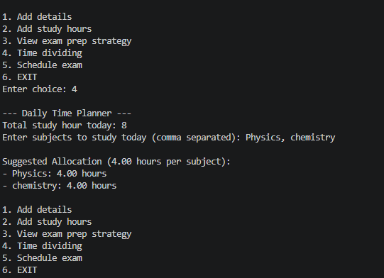

- Scheduling time:
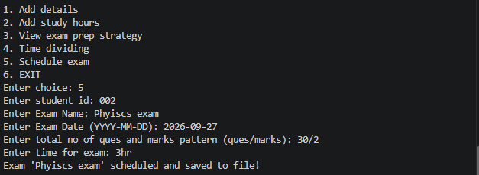
- Exit
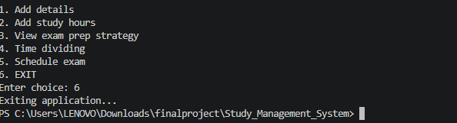
6.error handling:
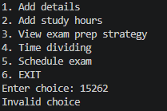
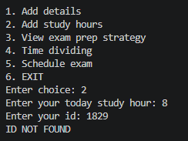
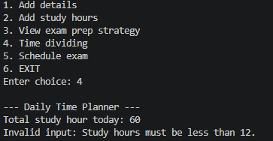

Representative console output is included above as the project result. The packaged source also includes student_data.txt as the persistent sample data file.

10. Testing Approach
Test | Input/Action | Expected result | Status
Program startup | Run main.py | Menu displayed and program accepts a choice | Pass
Student addition | Use option 1 with a new numeric ID | Student record saved | Pass
Duplicate ID | Use option 1 with an existing ID | Duplicate-ID message displayed | Pass
Study hours | Use option 2 with a valid ID | Study hours updated and saved | Pass
Time division | Use option 4 with hours < 12 and subjects | Equal allocation displayed | Pass
Exam scheduling | Use option 5 with valid ID | Exam appended and saved | Pass
Exit | Use option 6 | Application exits | Pass

11. Challenges Faced
- Separating the original single-file program into modules without changing the names of its defined functions.
- Preserving the existing text-file format while keeping exam information readable and writable.
- Handling user input and file operations in a way that avoids unnecessary program termination.

12. Learnings & Key Takeaways
- Understanding how a procedural Python program can be divided into modules.
- Using dictionaries and lists to represent structured student and exam data.
- Using file handling for lasting storage.
- Using functions to isolate application features.
- Using exception handling for common invalid-input and file conditions.
- Understanding basic software documentation and project-report structure.

13. Future Enhancements
- Add update and delete operations for student records.
- Add a student-search and record-view feature.
- Validate exam dates and times more strictly.
- Replace the text file with SQLite for larger datasets.
- Add automated unit tests.
- Add a graphical interface using Tkinter.
- Add login and role-based access if the system is expanded.

14. References
1. VITyarthi, “Build Your Own Project – General Project Instructions & Submission Guidelines,” uploaded project guideline used as the report structure.
2. Python standard library concepts used by the project: file handling, lists, dictionaries, functions, modules, loops, conditionals, and exception handling.
3. Project source files included in this submission package.

15. Complete Source Code
The complete modularized source code is reproduced below. The original function names are retained.

storage.py
FILENAME = "student_data.txt"

def infooload():
details = []
try:
with open(FILENAME, "r") as file:
for line in file:
line = line.strip()
if not line:
continue
criteria = line.split(",")
if len(criteria) >= 7:
detail = {
"id": int(criteria[0]),
"NAME": criteria[1],
"standard": criteria[2],
"subject": criteria[3],
"result": criteria[4],
"nature": criteria[5],
"studyhour": int(criteria[6]),
"exams": []
}

if len(criteria) > 7 and criteria[7]:
exam_entries = criteria[7].split("|")
for entry in exam_entries:
parts = entry.split(";")
if len(parts) == 4:
detail["exams"].append({
"examname": parts[0],
"date": parts[1],
"exampattern": parts[2],
"examtime": parts[3]
})

details.append(detail)
except FileNotFoundError:
pass
return details

def savesinfo(details):
"""Writes details and exams to student_data.txt."""
with open(FILENAME, "w") as file:
for detail in details:
exams_str = ""
if "exams" in detail and detail["exams"]:
exam_list = []
for ex in detail["exams"]:
exam_list.append(
f"{ex['examname']};{ex['date']};"
f"{ex['exampattern']};{ex['examtime']}"
)
exams_str = "|".join(exam_list)

line = (
f"{detail['id']},{detail['NAME']},{detail['standard']},"
f"{detail['subject']},{detail['result']},{detail['nature']},"
f"{detail['studyhour']},{exams_str}\n"
)
file.write(line)

state.py
from storage import infooload

# Load existing data at startup.
details = infooload()

students.py
from storage import savesinfo
from state import details

def f1(): # Add details
print("\n--- Add Student Details ---")
try:
student_id = int(input("Enter Your id: "))
except ValueError:
print("Please enter a valid numeric ID.")
return

for detail in details:
if detail["id"] == student_id:
print(f"Error: A student with ID {student_id} already exists.")
return

name = input("Enter Your Name: ")
standard = input("Enter the class: ")
sub = input("Enter the subjects: ")
result = input("Enter your result: ")
nature = input("Enter your study pattern (night/morning): ")

detail = {
"id": student_id,
"NAME": name,
"standard": standard,
"subject": sub,
"result": result,
"nature": nature,
"studyhour": 0,
"exams": []
}

details.append(detail)
savesinfo(details)
print(f"ID {student_id} saved to file!")

study.py
from storage import savesinfo
from state import details

def f2(): # study hours
try:
stdhour = int(input("Enter your today study hour: "))
x = int(input("Enter your id: "))
except ValueError:
print("Please enter valid numeric values.")
return

for detail in details:
if detail["id"] == x:
detail["studyhour"] = stdhour
savesinfo(details)
print(f"Your today study hour is {stdhour}.")
return
print("ID NOT FOUND")

def f3(): # exam paper strategy
for detail in details:
if detail["nature"].lower() == "night":
print(
"1. An effective night learner strategy focuses on optimizing your environment\n"
"2. Managing energy levels\n"
"3. Applying active recall techniques to stay alert and retain information after dark"
)
else:
print(
"1. An effective morning routine for learners focuses on waking up the brain\n"
"2. Protecting focus\n"
"3. Building steady energy for studying"
)

def f4(): # study hour management
print("\n--- Daily Time Planner ---")
try:
hours = float(input("Total study hour today: "))
if hours < 12:
raw_subjects = input("Enter subjects to study today (comma separated): ")
subjects = [s.strip() for s in raw_subjects.split(",") if s.strip()]
if subjects:
per_subject = hours / len(subjects)
print(f"\nSuggested Allocation ({per_subject:.2f} hours per subject):")
for sub in subjects:
print(f"- {sub}: {per_subject:.2f} hours")
else:
print("Invalid input: Study hours must be less than 12.")
return
except ValueError:
print("Invalid input")

exams.py
from storage import savesinfo
from state import details

def f5(): # schedule exam
try:
x = int(input("Enter student id: "))
except ValueError:
print("Please enter a valid numeric ID.")
return

for detail in details:
if detail["id"] == x:
if "exams" not in detail:
detail["exams"] = []

exname = input("Enter Exam Name: ")
exdate = input("Enter Exam Date (YYYY-MM-DD): ")
expattern = input(
"Enter total no of ques and marks pattern (ques/marks): "
)
time = input("Enter time for exam: ")

detail["exams"].append({
"examname": exname,
"date": exdate,
"exampattern": expattern,
"examtime": time
})

savesinfo(details)
print(f"Exam '{exname}' scheduled and saved to file!")
return
print("ID NOT FOUND")

main.py
from students import f1
from study import f2, f3, f4
from exams import f5

print("____STUDY MANAGEMENT SYSTEM___")

choice = " "
while choice != "6":
print("\n1. Add details")
print("2. Add study hours")
print("3. View exam prep strategy")
print("4. Time dividing")
print("5. Schedule exam")
print("6. EXIT")

choice = input("Enter choice: ").strip()

if choice == "1":
f1()
elif choice == "2":
f2()
elif choice == "3":
f3()
elif choice == "4":
f4()
elif choice == "5":
f5()
elif choice == "6":
print("Exiting application...")
break
else:
print("Invalid choice")

Appendix A – Project Files
- main.py
- storage.py
- state.py
- students.py
- study.py
- exams.py
- student_data.txt
- README.md
- statement.md
- SOURCE_CODE.txt

